QUAD HELIX EXPANDER

Q What is a crossbite?

A A crossbite is when the teeth come together but either inside or totally outside their correct positions. The most common crossbite occurs when the top back teeth are inside the lowers usually on one side only.

Q How can a crossbite be rectified?

A In the most common occurring crossbite, the upper tooth arch can be widened.

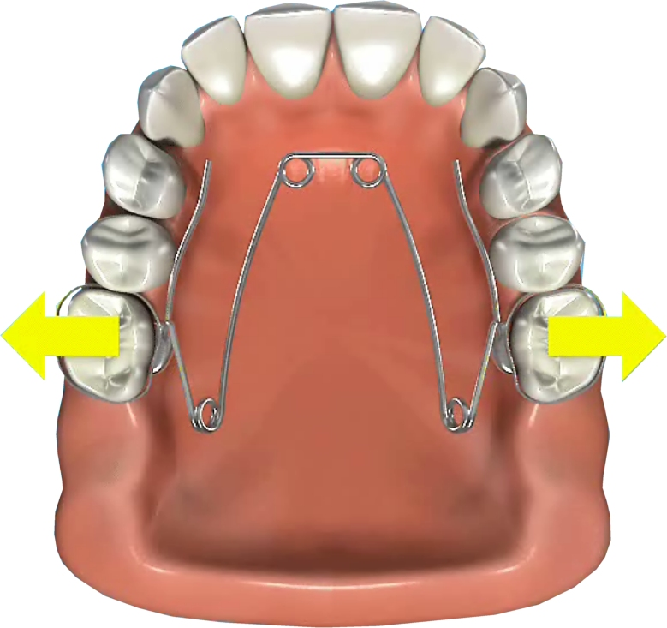
Q What is a Quad Helix Expander?

A A Quad Helix Expander is a fixed brace designed to widen the upper tooth arch. It has four loops and is shaped like the letter ‘W’.

Q How does the Quad Helix Expander work?

A The Quad Helix Expander is compressed on fitting so it gradually expands and pushes the back teeth outwards.

Q Will it hurt?

A There will be some initial very mild discomfort.

Q How long will the Quad Helix Expander need to be in place?

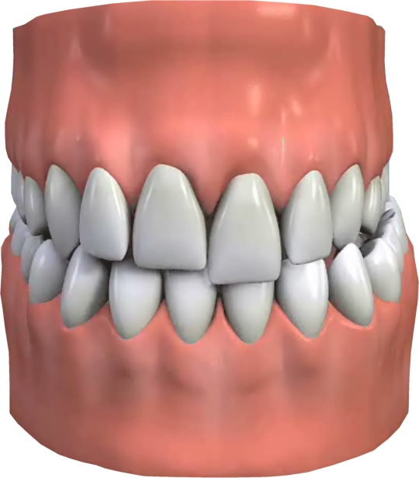
A The Quad Helix Expander will usually need to be in place for three months to correct a crossbite and then another three months to hold the correction i.e. six months is the anticipated total time for the expander to be in place.

Q Will there be any permanent damage?

A The Quad Helix Expander does not cause any permanent damage.

Q Is the treatment permanent, or will I need additional future treatment?

A The crossbite will need to be retained for at least one year after the Quad Helix Expander is removed, to prevent it reverting to its original position. A retainer (removable brace) will be fitted for this purpose.

Q How successful will it be?

A In the long term this will depend on the correct use of the retainer after the Quad Helix Expander has been removed.

